SQL Injection

🌟 Definition
# Source: AI Source: Provided by: [Data Path: Persons Table -> ID Column: 1, Name_En Column: Motasem Essam] -> From: [ChatGPT] on [6/11/2026]
SQL Injection (SQLi) is a cybersecurity attack where an attacker inserts malicious SQL code into an application's input fields to manipulate the database.
It happens when user input is directly included in SQL queries without proper validation or protection.

🎯 Goal of SQL Injection Attacks
# Source: AI Source: Provided by: [Data Path: Persons Table -> ID Column: 1, Name_En Column: Motasem Essam] -> From: [ChatGPT] on [6/11/2026]
Attackers may try to:
- View sensitive data
- Bypass login systems
- Modify database records
- Delete data
- Gain unauthorized access
- Take control of the application

🧠 How SQL Injection Happens
# Source: AI Source: Provided by: [Data Path: Persons Table -> ID Column: 1, Name_En Column: Motasem Essam] -> From: [ChatGPT] on [6/11/2026]
Imagine a login form:
Username: ______
Password: ______
The application creates a query like:
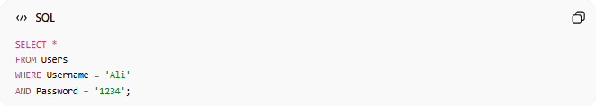
SELECT *
FROM Users
WHERE Username = 'Ali'
AND Password = '1234';
This works normally.

⚠️ Vulnerable Code Example
# Source: AI Source: Provided by: [Data Path: Persons Table -> ID Column: 1, Name_En Column: Motasem Essam] -> From: [ChatGPT] on [6/11/2026]
Suppose the application builds SQL like this:
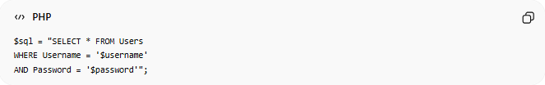
$sql = "SELECT * FROM Users
WHERE Username = '$username'
AND Password = '$password'";
User input is directly inserted into the query.
This is dangerous.

🚨 SQL Injection Example
# Source: AI Source: Provided by: [Data Path: Persons Table -> ID Column: 1, Name_En Column: Motasem Essam] -> From: [ChatGPT] on [6/11/2026]
Attacker enters:
Username
admin
Password
' OR '1'='1
Resulting query:
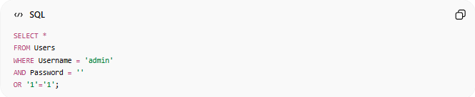
SELECT *
FROM Users
WHERE Username = 'admin'
AND Password = ''
OR '1'='1';

Since:
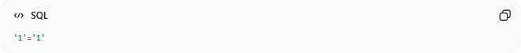
'1'='1'
is always true,
the login may succeed without knowing the real password.

🔍 Another Example
# Source: AI Source: Provided by: [Data Path: Persons Table -> ID Column: 1, Name_En Column: Motasem Essam] -> From: [ChatGPT] on [6/11/2026]
User enters:
' OR 1=1 --
Query becomes:
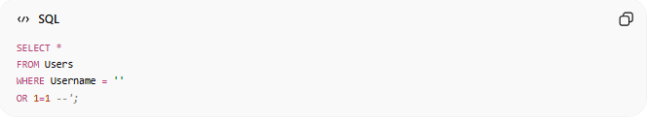
SELECT *
FROM Users
WHERE Username = ''
OR 1=1 --';

Meaning:
OR 1=1
is always true.
The -- turns the rest into a comment.
This can return all users.

📚 Common SQL Injection Targets
# Source: AI Source: Provided by: [Data Path: Persons Table -> ID Column: 1, Name_En Column: Motasem Essam] -> From: [ChatGPT] on [6/11/2026]
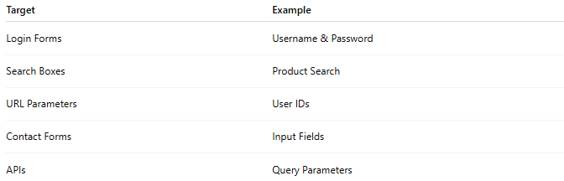
Target | Example
Login Forms | Username & Password
Search Boxes | Product Search
URL Parameters | User IDs
Contact Forms | Input Fields
APIs | Query Parameters

🚫 Potential Damage
# Source: AI Source: Provided by: [Data Path: Persons Table -> ID Column: 1, Name_En Column: Motasem Essam] -> From: [ChatGPT] on [6/11/2026]
Attackers may:
Read Data
SELECT * FROM Customers;

Modify Data
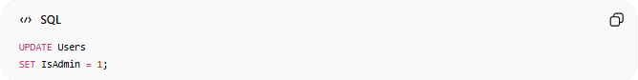
UPDATE Users
SET IsAdmin = 1;

Delete Data
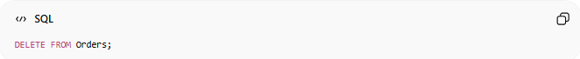
DELETE FROM Orders;

Drop Tables
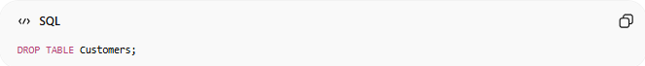
DROP TABLE Customers;

⚖️ Vulnerable vs Secure Code
# Source: AI Source: Provided by: [Data Path: Persons Table -> ID Column: 1, Name_En Column: Motasem Essam] -> From: [ChatGPT] on [6/11/2026]
❌ Vulnerable
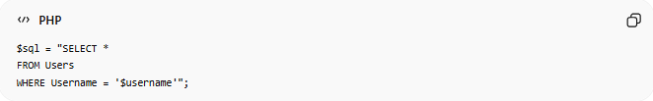
$sql = "SELECT *
FROM Users
WHERE Username = '$username'";
User input is directly concatenated.

✅ Secure
Using Prepared Statements:
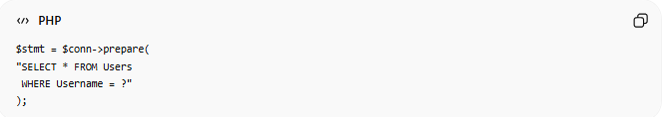
$stmt = $conn->prepare(
"SELECT * FROM Users
WHERE Username = ?"
);
User input is treated as data, not SQL code.

🛡️ How to Prevent SQL Injection
# Source: AI Source: Provided by: [Data Path: Persons Table -> ID Column: 1, Name_En Column: Motasem Essam] -> From: [ChatGPT] on [6/11/2026]
1. Use Prepared Statements
Most important protection.
Example:
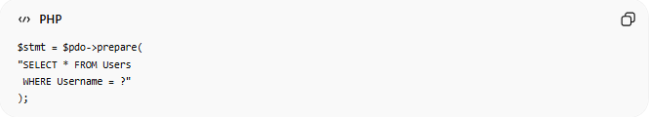
$stmt = $pdo->prepare(
"SELECT * FROM Users
WHERE Username = ?"
);

2. Parameterized Queries
Separate:
SQL Code
From
User Data

3. Validate Input
Check:
- Length
- Format
- Allowed characters
Example:
Only numbers allowed for UserID

4. Escape Special Characters
Some systems provide escaping functions.
However:
Prepared Statements
are preferred.

5. Least Privilege Principle
Database accounts should only have required permissions.
Example:
Read-only user
instead of:
Database administrator

📊 Example Attack Flow
# Source: AI Source: Provided by: [Data Path: Persons Table -> ID Column: 1, Name_En Column: Motasem Essam] -> From: [ChatGPT] on [6/11/2026]
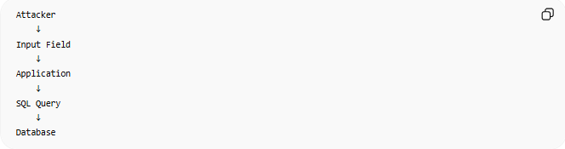
Attacker
↓
Input Field
↓
Application
↓
SQL Query
↓
Database
If input is not protected:
Malicious SQL executes

🔢 Characteristics of SQL Injection
# Source: AI Source: Provided by: [Data Path: Persons Table -> ID Column: 1, Name_En Column: Motasem Essam] -> From: [ChatGPT] on [6/11/2026]
SQL Injection:
- Exploits poor input handling
- Targets SQL databases
- Can expose sensitive information
- Can alter or destroy data
- Is one of the most well-known web vulnerabilities

🌍 Real-World Impact
# Source: AI Source: Provided by: [Data Path: Persons Table -> ID Column: 1, Name_En Column: Motasem Essam] -> From: [ChatGPT] on [6/11/2026]
Many historical breaches involved:
SQL Injection
because applications trusted user input without proper protection.
Modern frameworks often include protections, but developers must still use them correctly.

🧠 Simple Analogy
# Source: AI Source: Provided by: [Data Path: Persons Table -> ID Column: 1, Name_En Column: Motasem Essam] -> From: [ChatGPT] on [6/11/2026]
Imagine a receptionist asks:
"What is your name?"
A normal visitor answers:
Ali
An attacker instead gives instructions:
Ali and unlock every door
If the receptionist blindly follows the instructions, security is compromised.
SQL Injection works similarly:
- The application expects data.
- The attacker sends SQL commands.
- The database mistakenly executes them.

🧭 Summary
# Source: AI Source: Provided by: [Data Path: Persons Table -> ID Column: 1, Name_En Column: Motasem Essam] -> From: [ChatGPT] on [6/11/2026]
SQL Injection (SQLi) is a security vulnerability that occurs when malicious SQL code is inserted into application inputs and executed by the database. It can allow attackers to read, modify, delete, or bypass access controls on data. The most effective defenses are prepared statements, parameterized queries, proper input validation, and using least-privilege database accounts.

